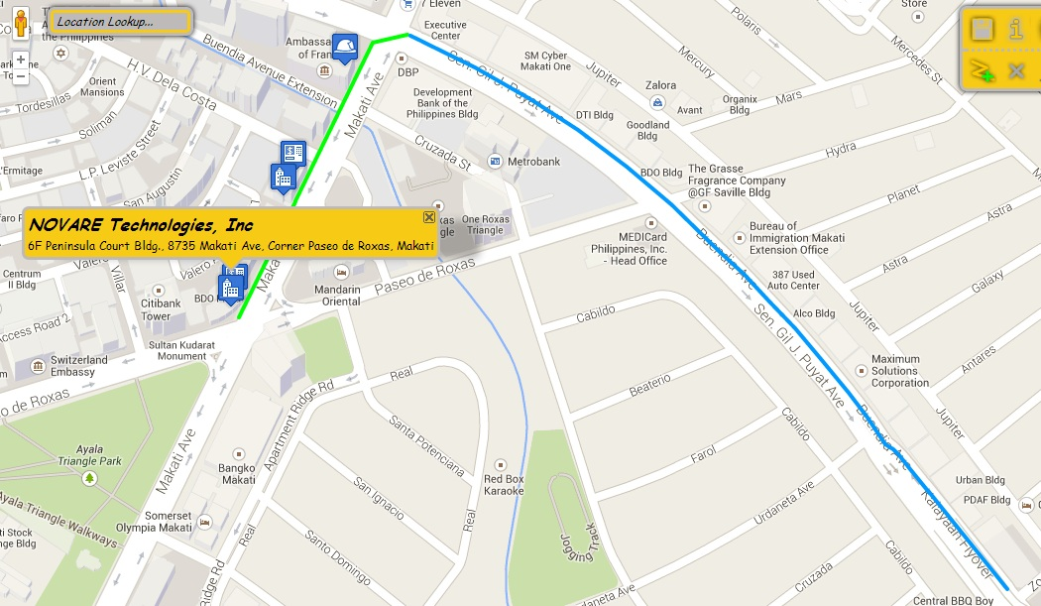
TIMES SQUARE food court
Banco De Oro Office
Generali Philippines

HSBC Branch

By Jeep
By Feet

Petron Station

After getting off the train, exit the Buendia MRT station then you will see a McDonald’s branch, beside it is a terminal of jeep going to Washington. Take a ride on it then get off the jeep when you see a petron station and pacific star building nearby. Then follow the green path indicated above. The entrance of the Peninsula Court building is beside HSBC and LBC then use an elevator to get to 6th floor.
FARE: 8 PHP

